**Deployment of Smart Contract using Ganache GUI, etherwallet and Remix IDE**

Tools needed to be downloaded and installed [Send through mail]

1. Ganache set up
2. Etherwallet
3. Remix IDE
4. After installing ganache GUI, it looks as given below

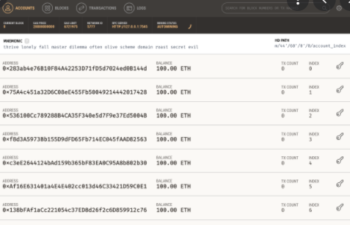

1. Unzip etherwallet and click on the index file, it will take you to the chrome browser as shown below

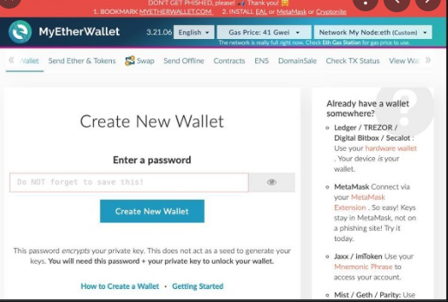

Steps to deploy smart contract

Step 1: Create a node on ethereum by clicking on Network My Node: Add Custom node and set up the custom node by mentioning

1. Node name: any user defined name
2. URL : RPC server / ganache ip address and port number where you have installed the ganache HTTP:// 127.0.0.1 port no 7545
3. Save and use custom node

Step 2: Deploy contract using etherwallet by providing bytecode from remix IDE.

1. Select contracts tab in myetherwallet and you have 2 options
   1. Interact with contract
   2. Deploy contract
2. To deploy contract
   1. Compile the smart contract in remix IDE and obtain the byte code [what is ABI & Bytecode]
   2. Paste the byte code from remix IDE to the textbox provided, keep only the numbers.
   3. Automatically gas limit comes
   4. How would you like to access your wallet
      1. Using private key [copy private key from any one of the accounts in ganache] and unlock. Will get message Wallet successfully decrypted.
      2. Click on sign transaction
      3. Deploy contract
      4. Give the consent to make new transaction and your transaction has been broadcasted to the network

Step 3: Interact with smart contract

1. Get contract address from ganache from the transactions tab take the created contract address copy paste in myetherwallet.
2. Get ABI from Remix IDE
3. Click on Access and you can see the deployed smart contract and can interact with it now.